Date: 05.09.2025
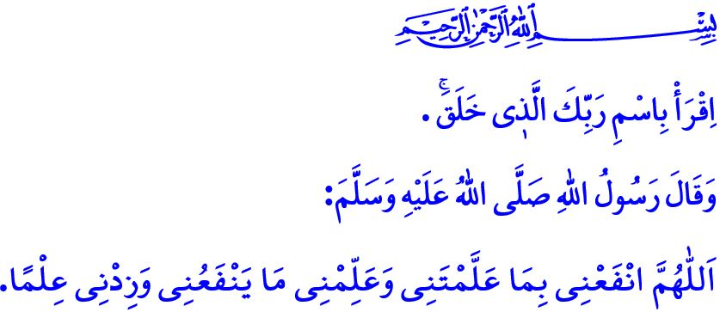
KNOWLEDGE IS TO ACKNOWLEDGE THE TRUTH
Honorable Muslims!
Our sublime religion, Islam, has made the pursuit of knowledge obligatory upon every Muslim, both men and women. Knowledge enables people to know themselves, to recognize their Lord, and to comprehend the purpose of their creation. The command, اِقْرَأْ بِاسْمِ رَبِّكَ الَّذ۪ي خَلَقَۚ “Read, ˹O Prophet,˺ in the Name of your Lord Who created!” informs us that acquiring knowledge must be done in the name of Allah and for His pleasure.
Dear Believers!
According to Islam, knowledge is not merely a competition pursued for profession, career, or worldly gain. At the core of the knowledge that Allah has commanded to be sought and that our Prophet (saw) has guided lies placing the Qur’an at the center of life. It is about engraving the love of Allah and His Messenger into hearts. It is about establishing an understanding that honors the Creator and shows compassion to the creation. It is about replacing violence with affection, hatred with mercy, and enmity and hostility with love and respect. It is about raising generations who are faithful, moral, and virtuous.
Esteemed Muslims!
We have learned the value of knowledge from our beloved Prophet (saw). The Messenger of Allah (saw), who said, إِنَّمَا بُعِثْتُ مُعَلِّماً “Verily I have been sent as a teacher.” transformed Dar al-Arqam into a school of knowledge during the difficult days of Mecca, and turned the Masjid al-Nabawi into a center of wisdom in the very first days of Madinah. The Messenger of Allah (saw) encouraged us toward knowledge with the hadith: “Be either a teacher, a learner, a listener, or a supporter of knowledge. Do not be the fifth, lest you be ruined!” By saying, “Whoever takes a path upon which to obtain knowledge, Allah makes the path to Paradise easy for him,” he gave glad tidings of Paradise to students of knowledge and to teachers. Every teacher who takes the Noble Messenger (saw) as a guide should regard the time spent on education and instruction with the consciousness of worship and should see their students as a trust from Allah. They should first teach them faith in Allah and His Messenger; then show them the ways of becoming a good human being and a righteous Muslim, built upon values such as justice, mercy, good character, and awareness of what is halal and haram.
Dear Believers!
At the root of the problems we face in our time lies our failure to educate our children according to the command of our Lord and the noble character of our Prophet (saw). Today, unfortunately, some of our children fall into the trap of addiction at a very young age, some into the mire of virtual gambling; some are caught in the web of deviant ideologies, false beliefs, and misguided notions that corrupt their fitrah; some suffer under peer bullying, while others slip away from us in pursuit of fashion and imitation. Unfortunately, there are many children who are neglected by their parents and society, who are not raised according to our spiritual values, and who, being left at the mercy of wrongdoers, are driven into crime. The warning of our Prophet (saw) is perfectly clear: “No parent has given a child a gift more valuable than good upbringing.”
Dear Muslims!
The most important pillar of education and instruction after the family is the schools. Love, respect, and tolerance that are not taught at home and in school turn into anger and violence, bullying, and fighting in the streets. Likewise, justice, mercy, and decency that are not taught give rise to injustice, disorder, and immorality in society. Therefore, let us raise the children whom Allah has entrusted to us with the character of our beloved Prophet (saw), who said, “I was sent only to perfect good character.” Let us teach them the ways to distinguish good from evil and right from wrong. Let us, as families, schools, and society together, fulfill our responsibilities so that our children may be raised as individuals committed to our values. Let us regard the Culture of Religion and Knowledge of Ethics course taught in our schools as a great opportunity. Let us instill moral principles in our children both theoretically and practically. In addition, on the occasion of the 1500th anniversary of the birth of our Prophet (saw), let us ensure that more of our students this year select the courses The Life of the Prophet and the Qur’an in our schools with love, affection, and enthusiasm.

On this occasion, I pray to Allah the Almighty that the new academic year, which will once again bring millions of our children together with their schools, may be blessed. I would like to conclude this week’s khutbah with the following supplication of the Messenger of Allah (saw): “O Allah! Benefit me with that which You have taught me, and teach me that which will benefit me, and increase me in knowledge.”

‘Alaq, 96/1.
Ibn Majah, Sunnah, 17.
Darimi, Muqaddimah, 26.
Tirmidhi, ‘Ilm, 19.
Tirmidhi, Birr, 33; Ibn Hanbal, IV, 77.
Ibn Hanbal, II, 381.
Tirmidhi, Daawat 128; Ibn Majah, Sunnah, 23. General Directorate of Religious Services

